CSE OOPS ASSIGNMENT 2
SUBMITTED BY: ADITYA GUPTA CSE 3RD SEM 25103008
1. Write a C++ program to input marks of a student in five subjects, calculate the
percentage, and display the grade using if-else-if:
≥ 90: A+
80–89: A
70–79: B
60–69: C
50–59: D
&lt; 50: F
Also display whether the student has passed or failed.

CODE:
#include<bits/stdc++.h>
using namespace std;

class student{
public:

string calcGrade(int marks){
if(marks>=90){
return "A+";
}

else if(marks>=80){
return "A";
}
else if(marks>=70){
return "B";
}
else if(marks>=60){
return "C";
}
else if(marks>=50){
return "D";
}
else{
return "F";
}
}

bool isFail(int marks){
return (marks<50)?true:false;
}
};
int main(){

student s1;
for(int i=1;i<=5;i++){
cout<<"Enter Marks of "<<i<<" Subject: ";
int temp;
cin>>temp;
cout<<"Grade of Student: "<<s1.calcGrade(temp)<<endl;
if(s1.isFail(temp)){
cout<<"Student is Fail! Better Luck next time."<<endl;
}
}

return 0;

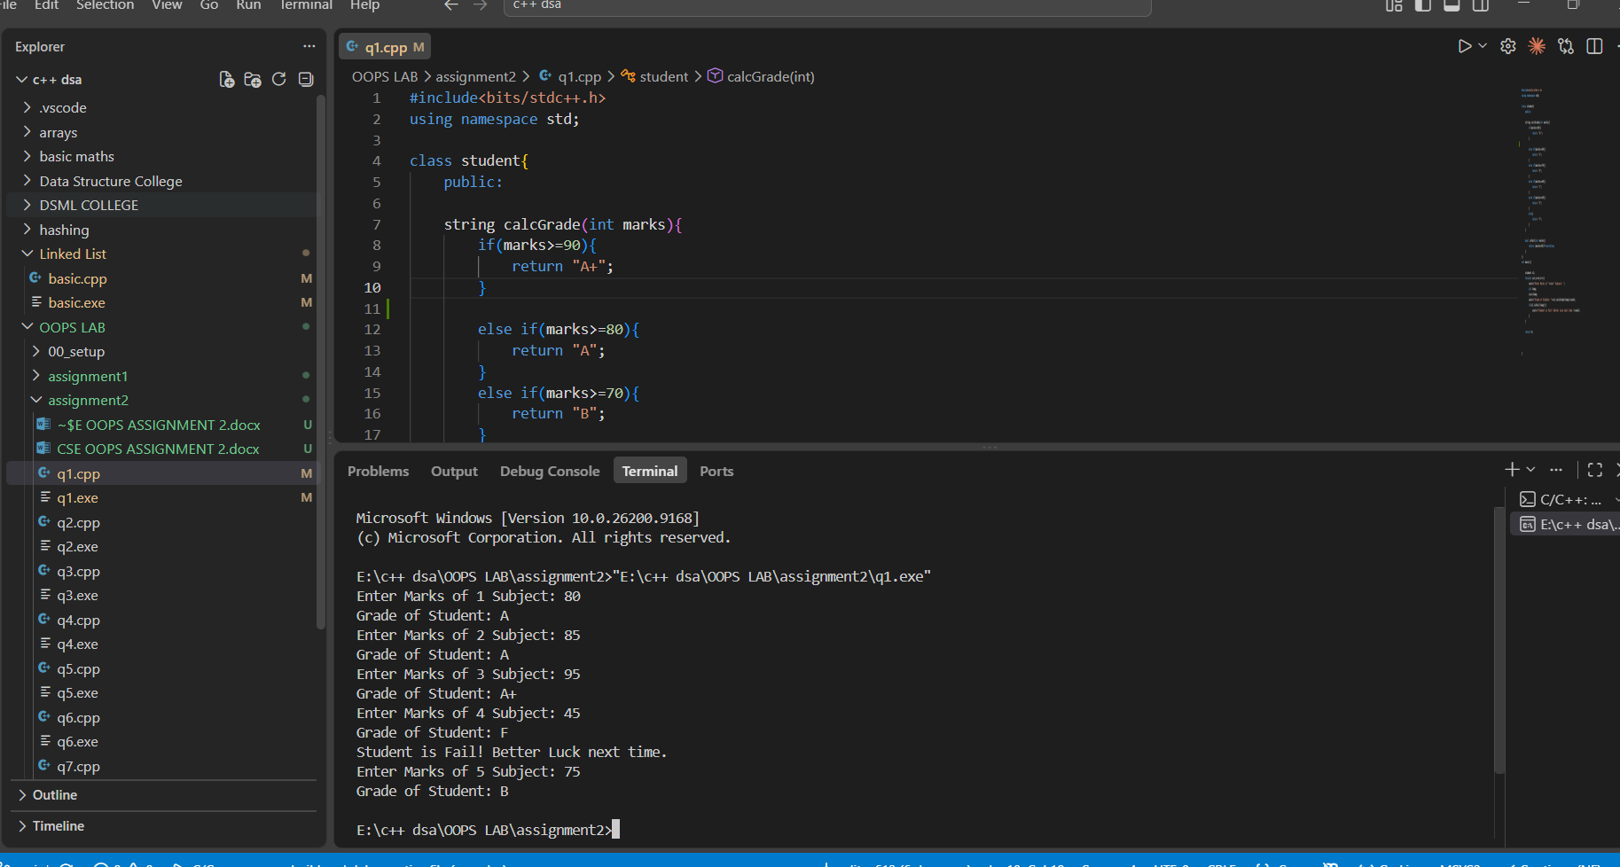
}

2. Write a program to input N integers and determine:

Number of positive numbers
Number of negative numbers
Number of zeros
Sum of positive numbers
Sum of negative numbers
Use loops and decision-making statements.
CODE:
#include<bits/stdc++.h>
using namespace std;
class student{
public:
vector<int> nums;

void insertNum(int num){
nums.push_back(num);
}

int positiveNums(){
int temp = 0;
for(auto i:nums){
if(i>0){
temp++;
}
}
return temp;
}

int negativeNums(){
int temp = 0;
for(auto i:nums){
if(i<0){
temp++;
}
}
return temp;
}

int numZeros(){
int temp = 0;
for(auto i:nums){
if(i==0){
temp++;
}
}
return temp;
}

int sumPositiveNums(){
int temp = 0;
for(auto i:nums){
if(i>0){
temp+=i;
}
}
return temp;
}

int sumNegativeNums(){
int temp = 0;
for(auto i:nums){
if(i<0){
temp+=i;
}
}
return temp;
}

};
int main(){

int N;
cout<<"Enter N: ";
cin>>N;

student s1;

for(int i=0;i<N;i++){
int temp;
cin>>temp;
s1.insertNum(temp);
}

cout<<"Number of positive numbers: "<<s1.positiveNums()<<endl;
cout<<"Number of negative numbers: "<<s1.negativeNums()<<endl;

cout<<"Number of Zeros: "<<s1.numZeros()<<endl;

cout<<"Sum of positive numbers: "<<s1.sumPositiveNums()<<endl;
cout<<"Sum of negative numbers: "<<s1.sumNegativeNums()<<endl;

}

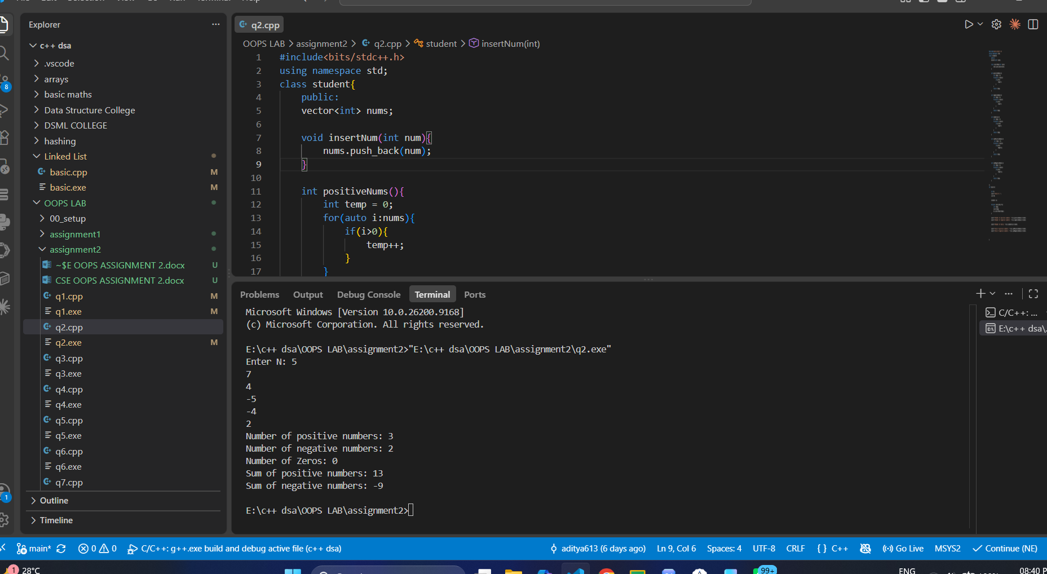

3. Write a menu-driven C++ program that repeatedly displays the following menu and
performs the selected computation. The program should terminate only when the user
selects Exit.
Menu:
i. Factorial of a Number
Input an integer N and calculate N! using a loop.
ii. Prime Number Check
Input an integer N and determine whether it is prime.
iii. Reverse and Palindrome Check
Input an integer N, reverse its digits, and determine whether the original
number is a palindrome.
iv. Armstrong Number Check
Input an integer N and determine whether it is an Armstrong number.
v. Perfect Number Check
Input an integer N and determine whether it is a perfect number.
vi. GCD and LCM

Input two integers A and B and calculate their GCD and LCM.
vii. Sum of Prime Numbers in a Range
Input two integers L and R and Display the sum and Count of all prime
numbers between L and R.
viii. Fibonacci Series
Input N and display the first N terms of the Fibonacci series and calculate their
sum.
ix. Strong Number Check
Input an integer N and determine whether it is a Strong number, i.e., whether
the sum of the factorials of its digits is equal to the original number.
x. Exit
CODE:
#include<bits/stdc++.h>
using namespace std;

class mathsFun{
public:

int factorial(int n){
int temp = 1;
for(int i=1;i<=n;i++){
temp*=i;
}
return temp;
}

bool primeCheck(int n){
if (n <= 1) return false;
for(int i=2;i*i<=n;i++){
if(n%i==0){
return false;
}
}

return true;
}

bool is_palindrome(int n){
int original = n;
int temp = 0;

while(n > 0){
temp = (temp * 10) + (n % 10);
n /= 10;
}

if(temp==original){
return true;
}
else{
return false;
}

}

bool is_armstrong(int n){
int original = n;
long long temp = 0;

while(n > 0){
int digit = n % 10;
temp += (long long)digit * digit * digit;
n /= 10;
}

if(temp==original){
return true;
}
else{
return false;
}
}

int calcGCD(int n1, int n2){
while (n2 != 0) {
int temp = n2;
n2 = n1 % n2;
n1 = temp;
}
return n1;

}

int calcLCM(int n1, int n2){
if (n1 == 0 || n2 == 0) return 0;

return (n1 / calcGCD(n1, n2)) * n2;

}

pair<int, int> sumAndCountPrime(int L, int R){
int sum=0;
int count=0;

for(int i=L;i<=R;i++){
if(primeCheck(i)){
count++;
sum+=i;
}
}

return {sum,count};
}

void fibonacciSeries(int n){
if(n <= 0) return;

int first = 0, second = 1, sum = 0;

for(int i = 1; i <= n; i++){
cout << first << " ";
sum += first;

int next = first + second;
first = second;
second = next;
}
cout << "\nSum of series: " << sum << endl;
}

bool is_strong(int n){
int original = n;
int temp = 0;

while(n > 0){
int digit = n % 10;
temp += factorial(digit);
n /= 10;
}

if(temp == original){
return true;
}
else{
return false;
}
}

};
int main(){

cout<<"MENU FOR MATHEMATICALS FUNCTIONS;"<<endl;

cout<<"Below is the menu to perform mathematical functions: Just select number to perform operation"<<endl;
cout<<"1. Factorial of a number"<<endl;
cout<<"2. Prime Number Check"<<endl;
cout<<"3. Reverse & Palindrome Check"<<endl;
cout<<"4. ArmStrong Number Check"<<endl;
cout<<"5. GCD of two numbers"<<endl;
cout<<"6. LCM of two numbers"<<endl;
cout<<"7. Sum & Count of prime numbers in range"<<endl;
cout<<"8. Fibonacci Series"<<endl;
cout<<"9. Strong Number check"<<endl;
cout<<"10. EXIT"<<endl<<endl;

mathsFun m1;

while(true){
cout<<"Enter num to perform operation: ";
int x;
cin>>x;
cout<<endl;

switch(x){
case 1: {
cout<<"Enter Num to calculate factorial: ";
int n;
cin>>n;
cout<<"Factorial: "<<m1.factorial(n)<<endl<<endl;
break;
}
case 2: {
cout<<"Enter Num to check prime: ";
int n;
cin>>n;
if(m1.primeCheck(n)){
cout<<n<<" is a prime number."<<endl<<endl;
} else {
cout<<n<<" is not a prime number."<<endl<<endl;
}
break;
}
case 3: {
cout<<"Enter Num to check palindrome: ";
int n;
cin>>n;
if(m1.is_palindrome(n)){
cout<<n<<" is a palindrome number."<<endl<<endl;
} else {
cout<<n<<" is not a palindrome number."<<endl<<endl;
}
break;
}
case 4: {
cout<<"Enter Num to check Armstrong: ";
int n;
cin>>n;
if(m1.is_armstrong(n)){
cout<<n<<" is an Armstrong number."<<endl<<endl;
} else {
cout<<n<<" is not an Armstrong number."<<endl<<endl;
}
break;
}
case 5: {
cout<<"Enter two numbers for GCD: ";
int n1, n2;
cin>>n1>>n2;
cout<<"GCD: "<<m1.calcGCD(n1, n2)<<endl<<endl;
break;
}
case 6: {
cout<<"Enter two numbers for LCM: ";
int n1, n2;
cin>>n1>>n2;
cout<<"LCM: "<<m1.calcLCM(n1, n2)<<endl<<endl;
break;
}
case 7: {
cout<<"Enter range (L and R): ";
int L, R;
cin>>L>>R;
pair<int, int> result = m1.sumAndCountPrime(L, R);
cout<<"Count of primes: "<<result.second<<endl;
cout<<"Sum of primes: "<<result.first<<endl<<endl;
break;
}
case 8: {
cout<<"Enter number of terms for Fibonacci: ";
int n;
cin>>n;
m1.fibonacciSeries(n);
cout<<endl;
break;
}
case 9: {
cout<<"Enter Num to check Strong: ";
int n;
cin>>n;
if(m1.is_strong(n)){
cout<<n<<" is a Strong number."<<endl<<endl;
} else {
cout<<n<<" is not a Strong number."<<endl<<endl;
}
break;
}
case 10: {
cout<<"Exiting program..."<<endl;
return 0;
}
default: {
cout<<"Invalid choice! Please select between 1 and 10."<<endl<<endl;
break;
}

}
}

}

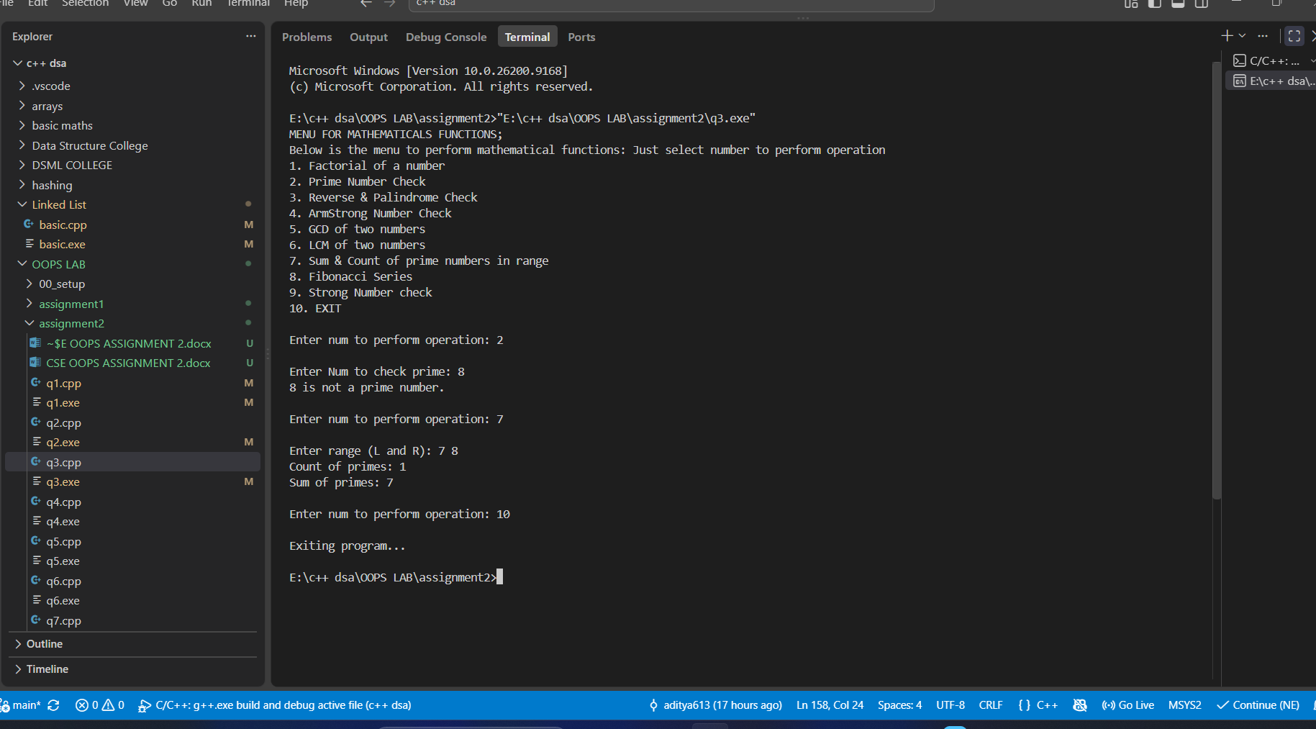

4. Write a program to print numbers from 1 to 100, but Skip numbers divisible by 3
using continue, and Stop execution when the number reaches 75 using break.
CODE:
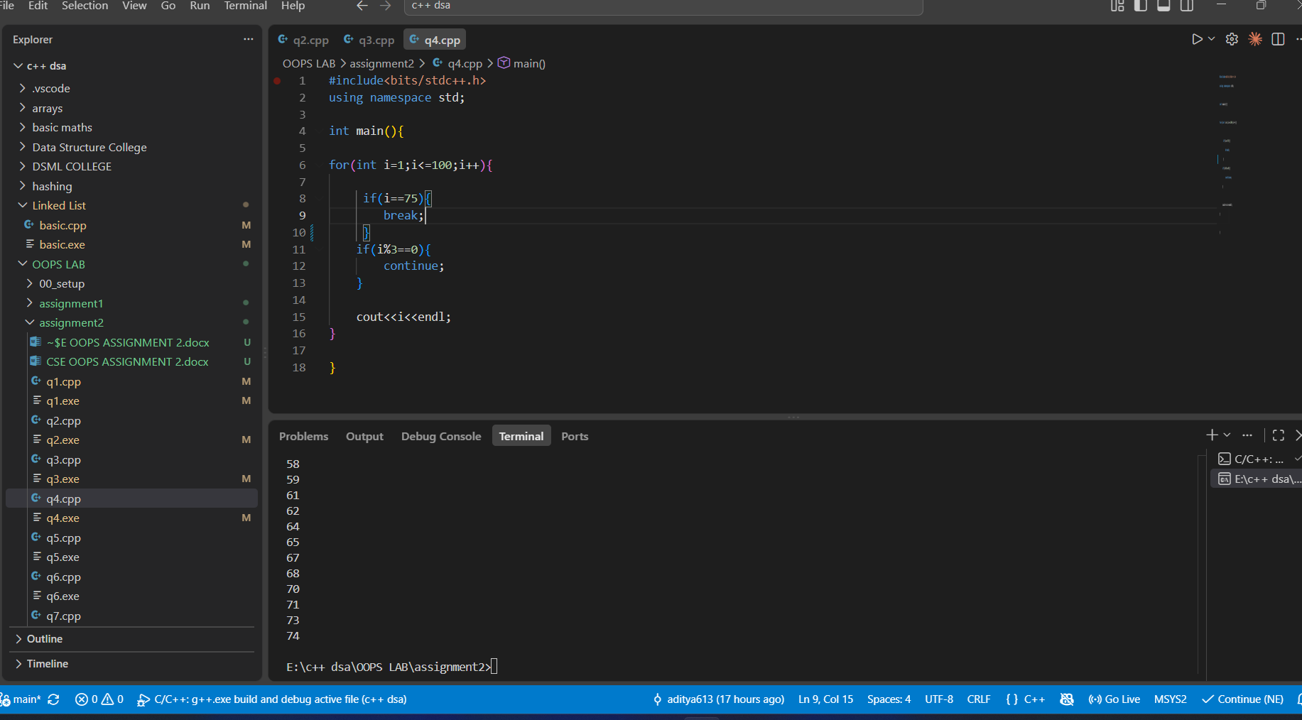

5. Write a program to input two integers a and b and find the first number between 1 and
1000 divisible by both. Use a loop and break.
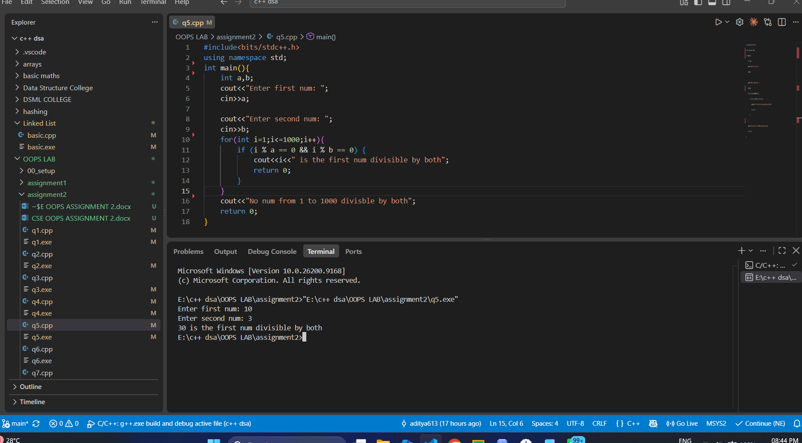
6. Write a program that continuously accept integers from the user and calculate their
sum. Ignore all zero values using continue and terminate input when a negative
number is entered using break.
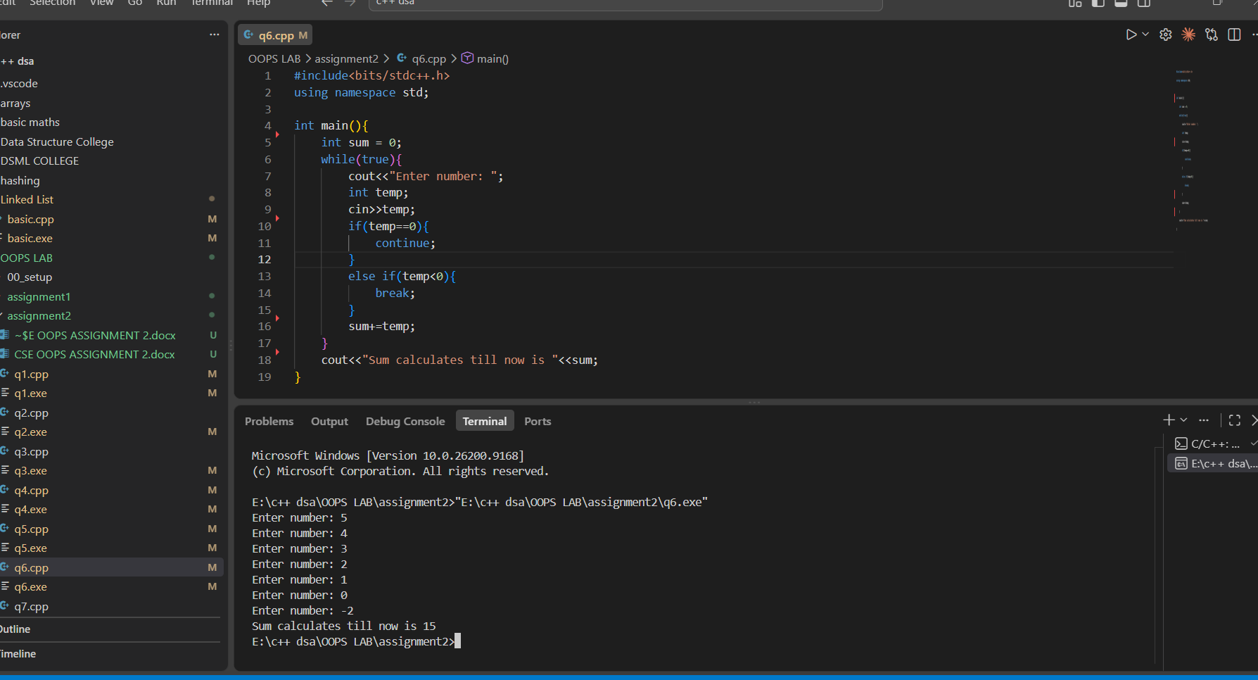
7. Write a program to find the first five prime numbers greater than 100. Use continue to
skip non-prime numbers and break once five primes have been found.
CODE:
#include<bits/stdc++.h>
using namespace std;

bool is_prime(int n){
for(int i=2;i<n;i++){
if(n%i==0){
return false;
}
}
return true;
}
int main(){

vector<int> primes;

int i=100;
while(true){
if(is_prime(i)){
primes.push_back(i);
i++;
}
else{
i++;
continue;
}
if(primes.size()==5){
break;
}
}
for(auto i:primes){
cout<<i<<endl;
}
}
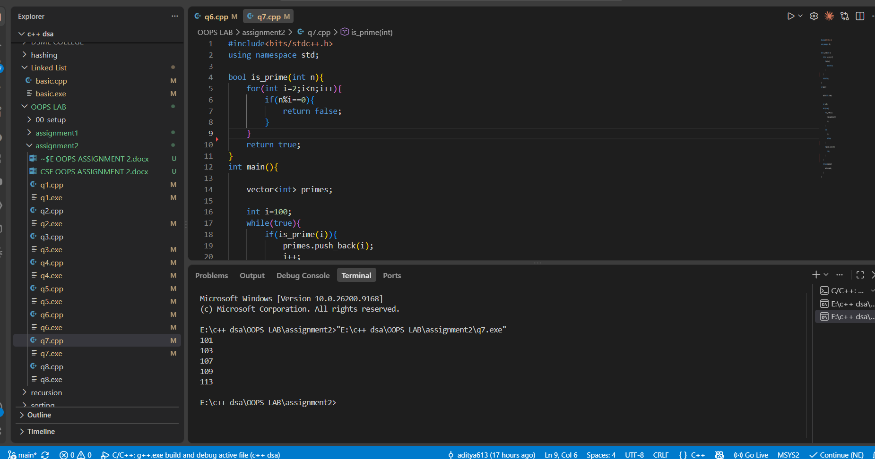

8. Write a menu-driven C++ program to print different complex pyramid patterns based
on the user&#39;s choice. The program should repeatedly display the menu until the user
selects Exit.
Menu:
CODE:
#include<bits/stdc++.h>
using namespace std;

void palidrome_number_pyramid(int n){

for(int i=1;i<=n;i++){

for (int j = 1; j <= n - i; j++) {
cout << " ";
}

for(int k=i;k>=1;k--){
cout<<k<<" ";
}
for(int z=2;z<=i;z++){
cout<<z<<" ";
}

cout<<endl;
}

}

void alpha_palindromic_pyramid(int n){

char arr[] = {'A', 'B', 'C', 'D', 'E', 'F', 'G', 'H', 'I', 'J'};
for(int i=1;i<=n;i++){

for (int j = 1; j <= n - i; j++) {
cout << " ";
}

for(int k=i;k>=1;k--){
cout<<arr[k-1]<<" ";
}
for(int z=2;z<=i;z++){
cout<<arr[z-1]<<" ";
}

cout<<endl;
}

}
void hollow_number_pyramid(int n){
for(int i = 1; i <= n; i++){
for(int j = 1; j <= n - i; j++){
cout << " ";
}
if(i == 1){
cout << "1";
}
else if(i == n){
for(int j = 1; j <= 2 * n - 1; j++){
cout << "1";
}
}
else{
cout << "1";
for(int j = 1; j <= 2 * (i - 1) - 1; j++){
cout << " ";
}
cout << "1";
}
cout << endl;
}
}

void inverted_number_pyramid(int n){
for(int i = 1; i <= n; i++){
for(int j = 1; j <= 2 * (i - 1); j++){
cout << " ";
}
for(int j = i; j <= n; j++){
cout << j << " ";
}
cout << endl;
}
}

void diamond_number_pattern(int n){
for(int i = 1; i <= n; i++){
for(int j = 1; j <= n - i; j++){
cout << " ";
}
for(int j = 1; j <= i; j++){
cout << j << " ";
}
cout << endl;
}
for(int i = n - 1; i >= 1; i--){
for(int j = 1; j <= n - i; j++){
cout << " ";
}
for(int j = 1; j <= i; j++){
cout << j << " ";
}
cout << endl;
}
}

void hollow_diamond_pattern(int n){
for(int i = 1; i <= n; i++){
for(int j = 1; j <= n - i; j++){
cout << " ";
}
for(int j = 1; j <= 2 * i - 1; j++){
if(j == 1 || j == 2 * i - 1){
cout << "*";
} else {
cout << " ";
}
}
cout << endl;
}
for(int i = n - 1; i >= 1; i--){
for(int j = 1; j <= n - i; j++){
cout << " ";
}
for(int j = 1; j <= 2 * i - 1; j++){
if(j == 1 || j == 2 * i - 1){
cout << "*";
} else {
cout << " ";
}
}
cout << endl;
}
}
int main(){

cout<<"Pyramid Patterns code menu "<<endl;
cout<<"1. Palindromic Number Pyramid"<<endl;
cout<<"2. Alphabetic Palindromic Pyramid"<<endl;
cout<<"3. Hollow Number Pyramid"<<endl;
cout<<"4. Inverted Number Pyramid"<<endl;
cout<<"5. Diamond Number Pattern"<<endl;
cout<<"6. Hollow Diamond Pattern"<<endl;
cout<<"7. EXIT"<<endl<<endl;
while(true){
cout<<"Enter Number to see output: ";
int temp;
cin>>temp;
cout<<endl;

cout<<"Enter N: ";
int n;
cin>>n;
switch(temp){
case 1:{
palidrome_number_pyramid(n);
break;
}
case 2:{
alpha_palindromic_pyramid(n);
break;
}
case 3:{
hollow_number_pyramid(n);
break;
}
case 4: {
inverted_number_pyramid(n);
break;
}
case 5: {

diamond_number_pattern(n);
break;

}
case 6: {
hollow_diamond_pattern(n);
break;
}
case 7: {
cout<<"Exiting program..."<<endl;
return 0;
}
default: {
cout<<"Invalid choice! Please select between 1 and 10."<<endl<<endl;
break;
}






